Action Verbs for Writing Objectives and Creating Learning Activities
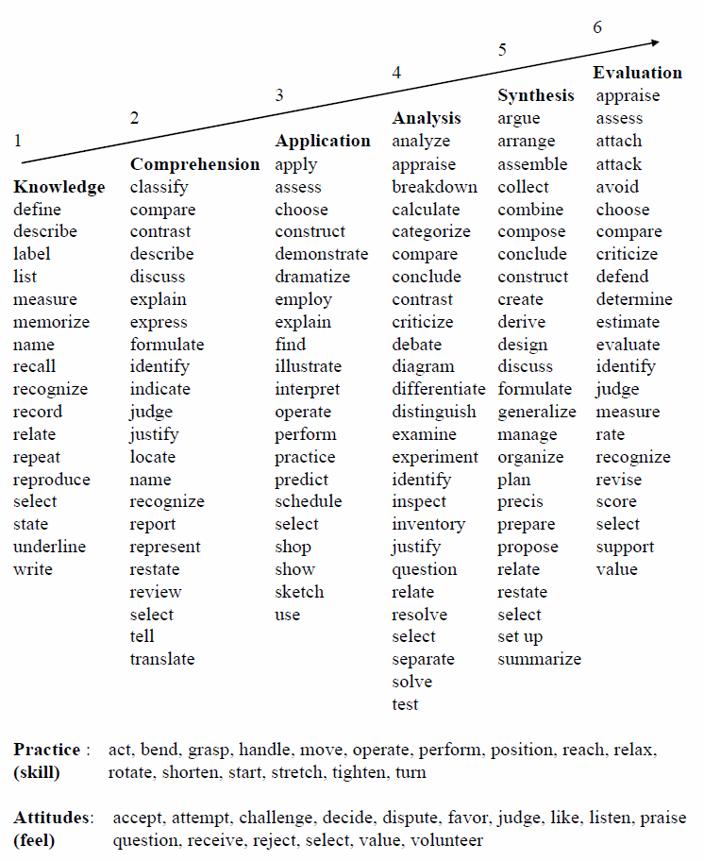

“Strong” Action Verbs for Writing Teaching Objectives
Appendix A From Dan Habben’s Symposium Paper 2015
Action verbs for writing teaching objectives should be: Measurable, Observable, Definable, Understandable. They can be applied to different levels of learning/performance in different domains. Here are examples of Action Verbs related to the Cognitive and Affective domains:

COGNITIVE DOMAIN
KNOWLEDGE
define, describe, identify, label, list, match, outline, reproduce, select, state

COMPREHENSION
convert, defend, distinguish, estimate, explain, extend, generalize, give example, infer, paraphrase, predict, rewrite, summarize

APPLICATION
change, compute, demonstrate, discover, manipulate, modify, operate, predict, prepare, produce, relate, show, solve, use

ANALYSIS
break down, differentiate, discriminate, distinguish, identify, illustrate, infer, outline, point out, relate, select, separate, subdivide

SYNTHESIS
categorize, combine, compile, compose, create, devise, design, explain, generate, modify, organize, plan, rearrange, revise, categorize, combine, compile, compose, create, devise, design, explain, generate, modify, organize, plan, rearrange, revise, rewrite, summarize, tell, write

EVALUATION
appraise, compare, conclude, contrast, criticize, discriminate, explain, justify, interpret, relate, summarize, support

AFFECTIVE DOMAIN
RECEIVING
ask, choose, describe, follow, give, hold, identify, locate, name, point to, select, reply, use

RESPONDING (active participation)
answer, assist, compile, conform, discuss, greet, help, label, perform, practise, present, read, recite, report, select, tell, write

VALUING (worth or value a student attaches to a particular object)
complete, describe, differentiate, explain, follow, form, initiate, invite, join, justify, propose, read, report, select, share, study, work

ORGANIZATION (bringing together different values)
adhere, alter, arrange, combine, compare, complete, defend, explain, generalize, identify, integrate, modify, order, organize, prepare, relate, synthesize

CHARACTERIZATION BY A VALUE
act, discriminate, display, influence, listen, modify, perform, practice, propose, qualify, question, revise, serve, solve, use, verify

Jane Vella also has a good summary regarding a teacher’s choice of verb when writing a lesson objective or learning task.
What verbs make a great learning task? Tough Verbs. By tough verbs I mean verbs that demand considered action, verbs that challenge a learner to stretch and grow. Design, edit, decide, select, write, distinguish x from y, illustrate, organize, solve, resolve, and realign are examples of what I call tough verbs. You can run, but you can’t hide from these verbs; they do not allow pedantic play or abstract meandering.
Productive Verbs. You want verbs in your learning tasks that produce for your learners – verbs such as list, design, compose, write, prepare, reorganize, select, develop, diagram, illustrate, and so on. These verbs produce, and the products are indicators of the learning that is taking place… One of the verbs I avoid in learning tasks is discuss. The reason I don’t use it is that there is no product of discuss; it can go on and on. It does not have the exhilarating immediacy in a learning task of verbs demanding a product such as design, create, list.

Anthony Kan, “Msg. #170 Teaching Objectives - Action Verbs” Tomorrow’s Professor (http://cgi.stanford.edu/~dept-ctl/tomprof/posting.php?ID=170), accessed May 3, 2015.
Jane Vella, Taking Learning to Task (San Francisco: Jossey-Bass, 2001), 52.

