8 Steps of Planning
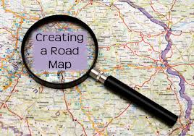

Who?

Why?

When?

Where?

What?

What For?

So That?

How?

